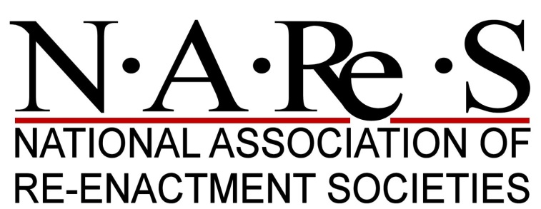

MEMBERSHIP APPLICATION FORM

As you would expect, as a national representative body for Re-enactment Societies to display organisers, promoters, national and international governments, NAReS has a set of guidelines to which all Societies wishing to re-apply for membership must conform. The guidelines are a minimum requirement for what may be considered a reasonably conscientious and ‘professional’ society. These criteria are laid out in the attached criteria for Membership. Please complete the following sections and return this form to the NAReS membership secretary with a copy of your PLI insurance for the coming year.

Name of Member Organisation
Ltd Company Number (if applicable)
Principal contact Name
Office/Role....
Correspondence address
Tel No:
E-Mail:
Key role contacts
Secretary/payments contact name
Tel No
E-Mail

Health & Safety Officer
Tel No
E-Mail

Period(s) re-created
Website address
Facebook ID
Other Online identities

Approximate adult members (please check/circle appropriate criteria):-

2 to 9 ☐ | 10 to 25 ☐ | 26 to 149 ☐ | 150 to 999 ☐ | 1,000 and above

Member Artefacts Check list
You currently hold Public Liability Insurance?  (Please include a copy of current insurance certificate or cover note) | YES | NO ☐
To the best of your knowledge and belief are the majority of your members only represented within NAReS by your organisation?  (If no please give details of their alternative representation) | YES | NO ☐
You maintained a Constitution and Regulations: | YES | NO ☐
You maintained a current Health & Safety policy? | YES | NO ☐
(If any of your organisation artefacts above have been significantly updated, please include a current version)

We hereby apply renew our NAReS as Full, Associate or Business members (delete that not required). NAReS will treat all information in confidence and the Executive Committee will be consulted on all matters of membership. We hereby agree to the use of photographs & images from our website by NAReS (providing they are not otherwise copywrited) for its display and promotional purposes and on its website.

Signed ................................................. Office held .................................................

Date......................................................

Print name............................................

Please send this form with a copy of your Public Liability Insurance via email to membership@nares.org.uk or via post to: NAReS Membership Secretary, The Old Grazing, Priory Wood, Clifford, HR3 5HG.
Please either include a Cheque payable to “National Association of Re-enactment Societies” or make payment via bank transfer to: “Lloyds TSB Bank plc, Fareham Branch – Sort code 30-93-17, Account number 01197321 for National Association of Re-enactment Societies” and notify NAReS of the reference and date of payment.
Should you have any question please contact the membership secretary via the email above. We’re keen to work with you to ensure your continued support for NAReS.

CRITERIA & FEEs FOR MEMBERSHIP

Membership of NAReS shall be of three kinds. Full, Associate and Business:

Full members must be re-enactment societies consisting of more than ten adult members. Societies will pay the following fee and have the right to send the indicated number of voting delegates to AGM and EGM’s. It should be noted that societies may send less than their allotted number of delegates but will retain the same number of overall votes that they are entitled to cast by their delegate(s) who are present:

Associate Adult Members
2 to 9 | No voting rights | £ 15 a year

Full member Adult membership strength of:-
10 to 25 | - 1 voting delegate | £ 30 per year
26 to 149 | - 2 voting delegates | £ 70 per year
150 to 999 | - 3 voting delegates | £ 100 per year
1,000 plus | - 4 voting delegates | £ 130 per year

Business members must be firms, companies or other commercial organisations that employ re- enactment societies in the course of their normal business activities. Such membership carries no votes at AGM and EGM’s. The Association reserves the right to exclude from meetings or part thereof any Business member that the meeting may find inappropriate. Cost is £25 per year. (please complete the NAReS Business Member application form)

Associate Members. This is for small groups of between 2 and 9 adult members, with a limitation of no votes at AGM’s or EGM’s, but takes that Associate Group into the NAReS ‘family’.

Please treat the above scale of Fees as an INVOICE for your category of payment and bring this form to the attention of your Treasurer or Paymaster, copying it to that person (terms of payment- settlement within 30 days please).

Please note, Membership of NAReS is not open to individuals as such BUT (as NAReS is a Company Limited by Guarantee) if your Society is a Limited Company, it will be a Member of NAReS on re- joining, represented by its voting delegates at a General Meeting, as below. However, if your Society is not a Ltd Co (i.e. it’s an unincorporated association) THEN the Chairman, Secretary & Treasurer have to become members of NAReS (for legal reasons) and they – or your chosen delegates – (numbers as below), represent your Society at a NAReS General Meeting (acting as Trustees).Any umbrella organisation representing more than one re-enactment society will be expected to be responsible for any group within its membership as if they were one society, both in adherence to the rules of NAReS and in regard to representation and will be deemed as such by the Association. Membership of NAReS is not open to individuals personally.

All applications to re-join the Association must be in writing/or email via the official application form issued by the Association.

All membership renewal applications must be supported by a copy of the current Public Liability Insurance cover maintained by the applicant appropriate to the activities carried out by that society. Applications for Full and Business membership will not be accepted from societies and organisations that are already wholly represented by another society or organisation.

NB. On renewal of Membership (which lasts for one calendar year) ONLY this form + copy of your insurance cover note for the year is required UNLESS you have changed your Constitution and/or H&S Policy: IF they have changed, copies are required of those, too, please.

Thank you for your help

NAReS Membership Secretary

PRIVACY STATEMENT

When you renew your organisation’s membership to NAReS, we ask for some contact information about you and additional officers of your organisation. This statement explains how we look after that information and what we do with it.

We have a legal duty under the General Data Protection Regulations to prevent your information falling into the wrong hands. We must also ensure that the data we hold is accurate, adequate, relevant and not excessive.

Normally the only information we hold comes directly from you. We collect name, email, post address and telephone details of the principle and additional contacts plus non-personal information relating to the organisation. Contact information is collected for communications purposes relating to the activities of NAReS. You do not have to provide us with any additional information unless you choose to. We store your information securely and restrict access to only those as required to discharge their duties as officers of NAReS. Our officers are made aware of need to handle the information securely.

Most of our contact with you will be by email. We will pass your contact details to members of the NAReS Executive Committee so that they can contact you with updates relevant to your organisation.

You have the right to a copy of all the information we hold about you. You may request to see a copy of this information at any time. To obtain a copy, please contact the Company Secretary by email at secretary@nares.org.uk . We aim to reply as promptly as we can and, in any case, within the legal maximum of 40 days.

